Main Agenda- Use pxUIGallery-ShoppingCart and display our own products

In the UI gallery Elements and then we can save as those into our own ruleset and then 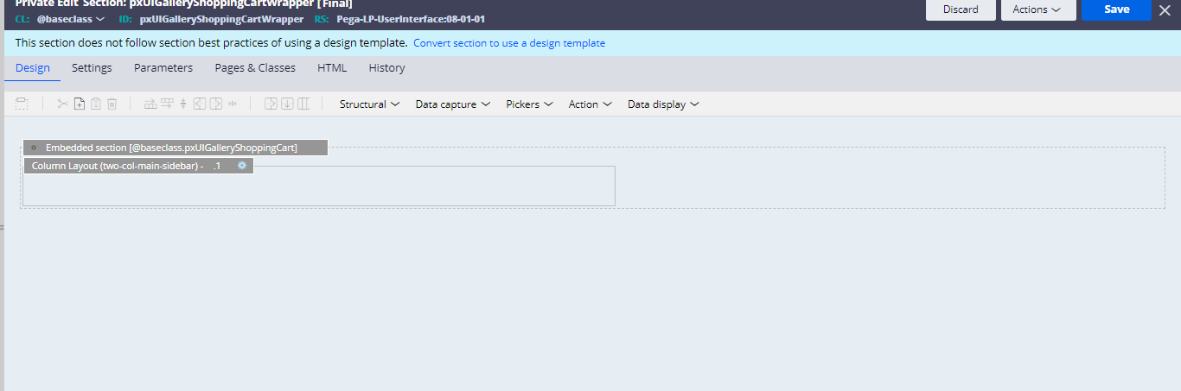

And inside this section we would be having the cart section

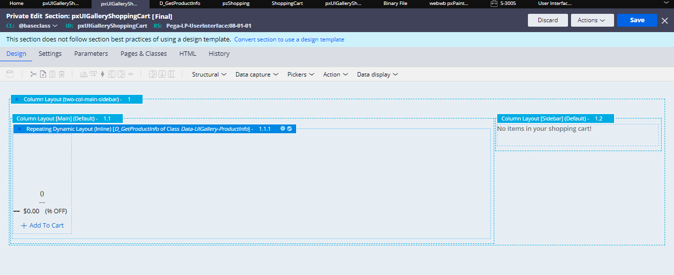

And the source of D_page and then we would be changing to our source of Datatransform “Map Products”

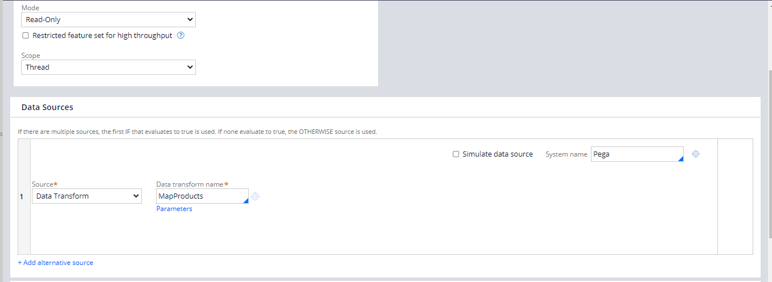

And inside that we would be giving our products and display names

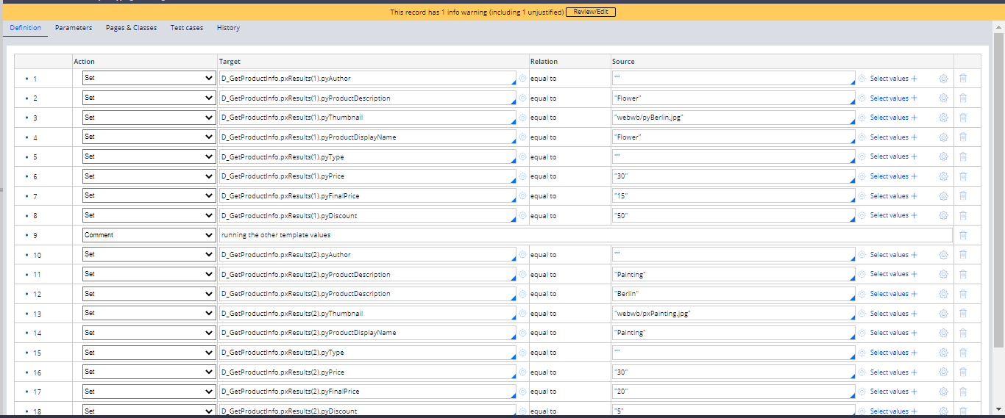

And we can get the results in the D page

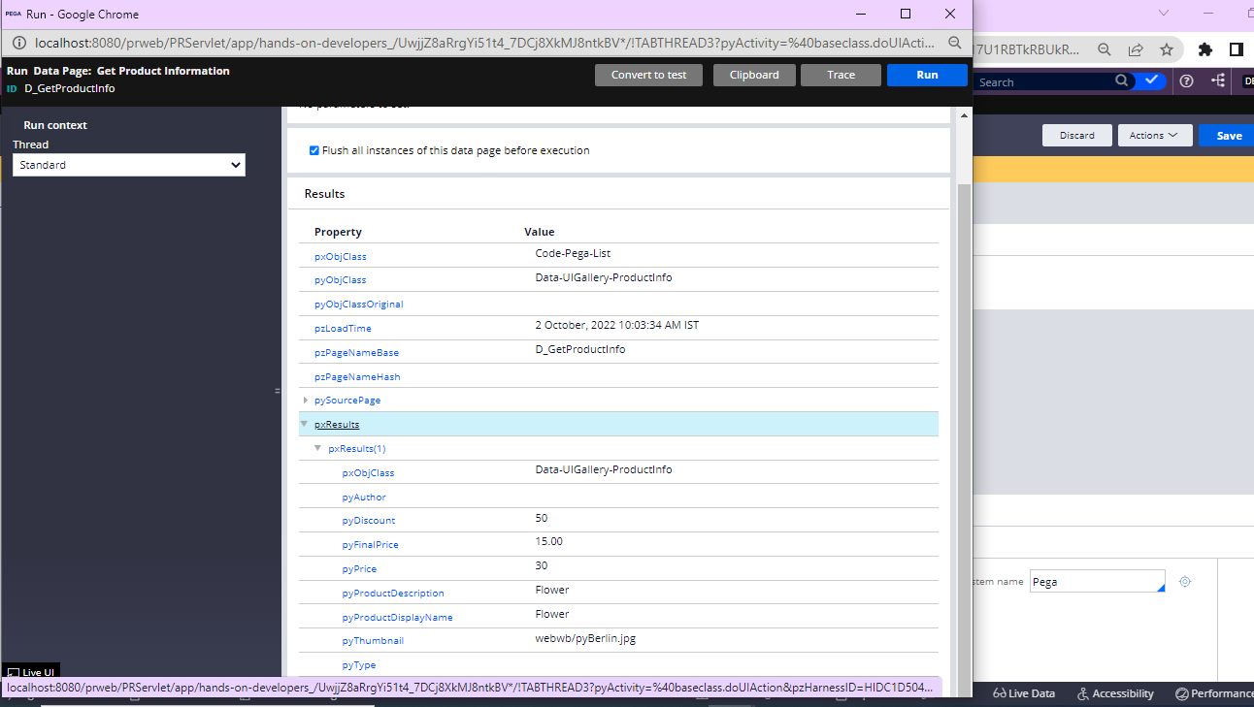

And then give this in our section and we would be obtaining the desired results and we can obtain the results

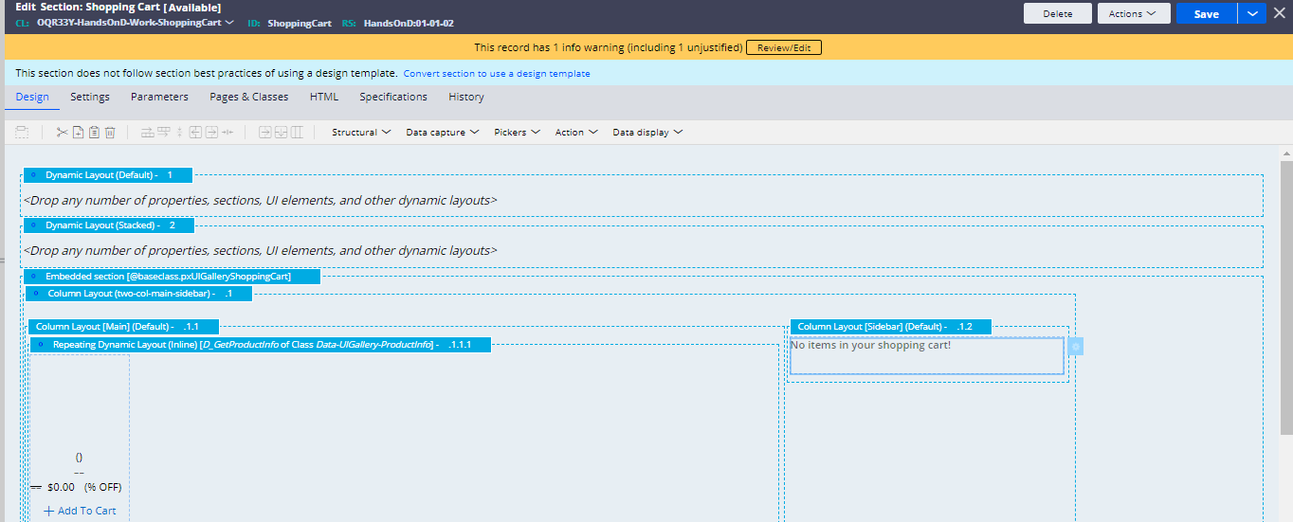

And the result would be like this

